LAB ACTIVITY 3.2: CSS STYLING
Name: Muhamad Asyraf bin Yang Budiman
Matric Number: CA24045
Part A: Create the Page Content
Screenshot:
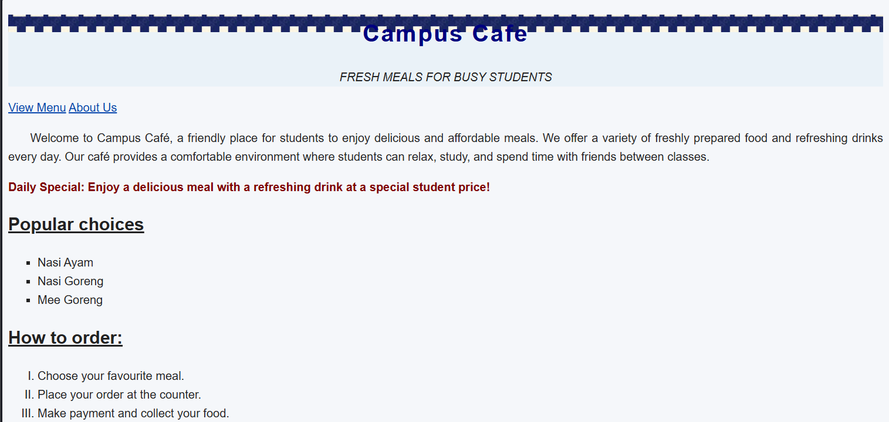
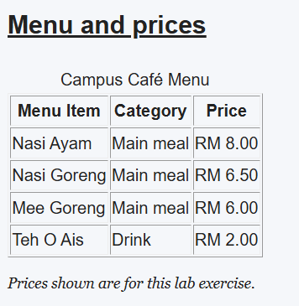
Part B: Backgrounds and Colour
Question 1: What is the difference between repeat-x and repeat-y?
repeat-x repeats the background image horizontally, while repeat-y repeats the background image vertically.

Question 2: Why is the image path images/tile.png correct when menu.css is next to menu.html?
The path is correct because the images folder is located in the same directory as menu.css. The browser uses the CSS file's location to find the image.
Question 3: What changed when you switched background-attachment from scroll to fixed?
When using scroll, the background image moves with its element as the page scrolls. When using fixed, the background image stays fixed relative to the browser viewport while scrolling.
Part C: Text and Font Styling
Question 1: Does text-transform: uppercase change the characters saved in the HTML source?
No. It only changes how the text appears in the browser. The original text in the HTML source remains unchanged.
Question 2: Why should a font-family declaration end with a generic family such as sans-serif?
A generic font family acts as a fallback if the preferred font is unavailable on the user's device.
Question 3: What do 14px and 1.5 represent in the font shorthand for .note?
14px represents the font size, while 1.5 represents the line height, which is 1.5 times the font size.

Part D: Links and Lists
Question 1: Explain the difference between and .
:hover applies styles when the mouse pointer is over an element, while :active applies styles when the element is being activated, such as when a mouse button is held down on a link.
Question 2: Which list property changes the marker into an image?
The list-style-image property changes the list marker into an image by using an image URL, such as list-style-image: url("images/marker.png");.

